**Authors and commits.**

After cleaning and extracting the refined data using python, I decided to use the following five variables as my pieces of interest which gave me the following findings. I used R and Tableau for analysing and visualization.

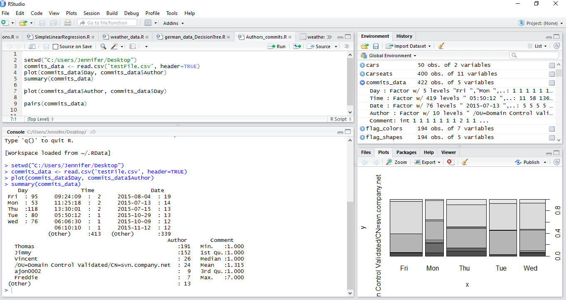

The above diagram gives a summary of the number of commits, authors, time, date and days of commits. The highest commits were done on Thursday with 118 and the lowest commits were done on Monday, only 53 commits.

The author who did a lot of commits was Thomas with 191 and Freddie with lowest though there were other authors who were excluded from the summary since there were no enough information to be analysed.

The commits were done from Monday to Friday only no weekends, they were done between July and November of 2015.

There were 7 maximum number of comments and less than 2 minimums. Most of the authors made less than one comment each time. Most commits were made in the month of July, August was the least on the commits. We also learn that most of the commits were done in the morning time few in the evening time.

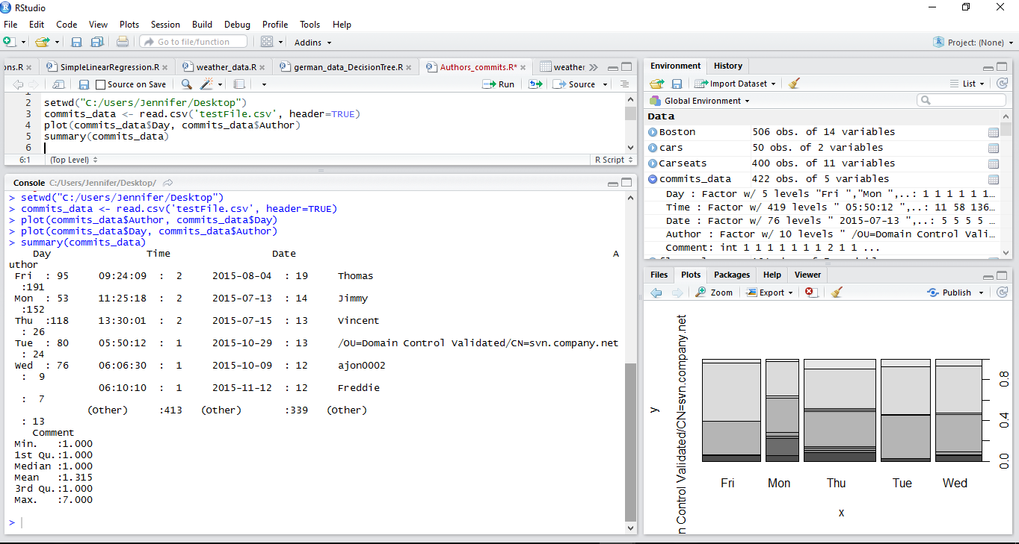

From the summary in R, we only got five authors though there were more authors, these are classified as others since they lacked sufficient data to be analysed.

In general, there were 422 observations (objects) made from 5 variables that I selected, the number of lines were 5255.

Below snapshot shows the authors with their days of their commits with highest on Friday done by Thomas and lowest on Wednesday.

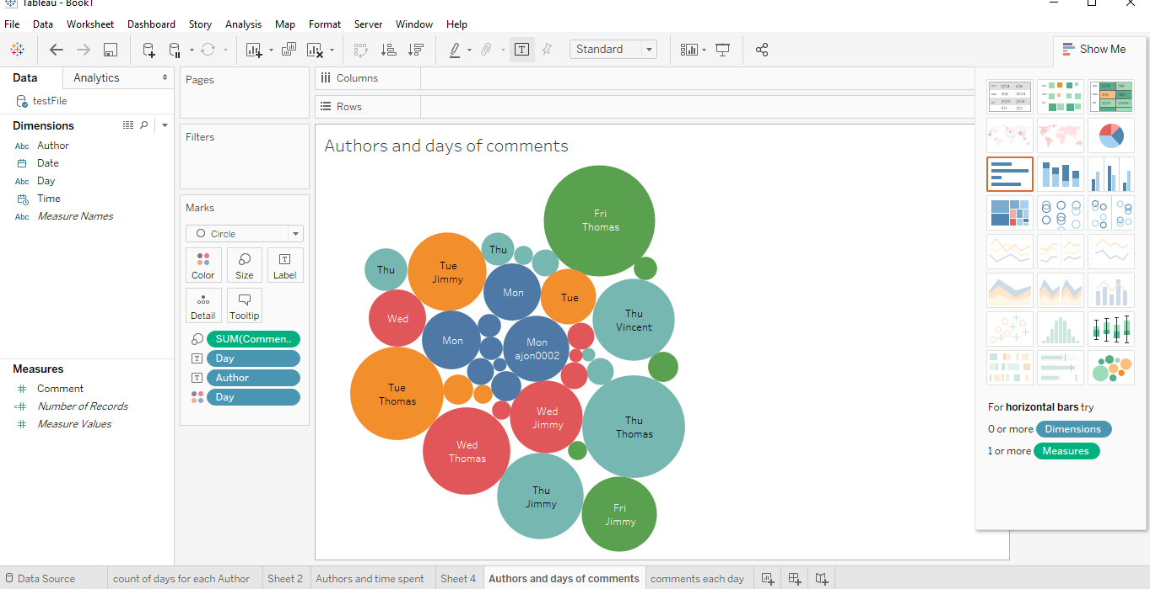

Below snapshot from tableau shows the day with the highest number of comments, which is Thursday similar with the same information given by R. Tableau has good visualisation it’s easier to discover some missing bits and pieces but in R the information is more defined, analysed in depth and it is much easier to interpret the results in one go.

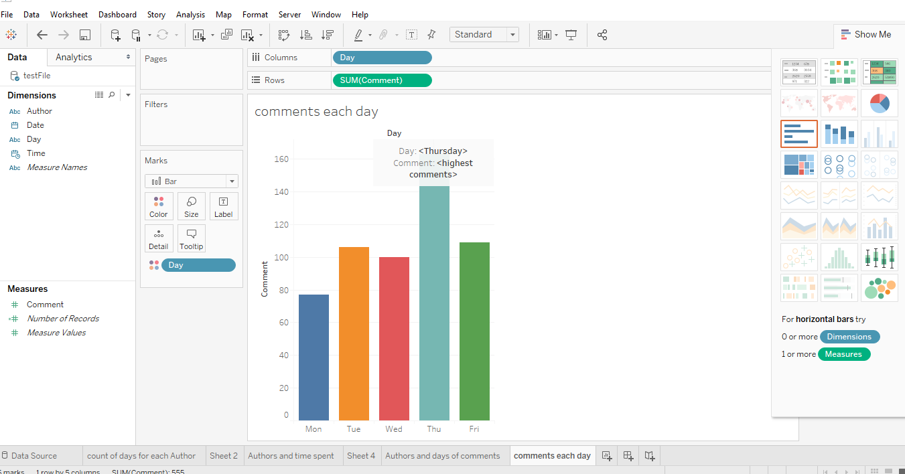

Thomas was the highest contributor on count of days similar with R. Freddie was the lowest amongst five of the authors analysed, the rest are not included though they also have the lowest count.

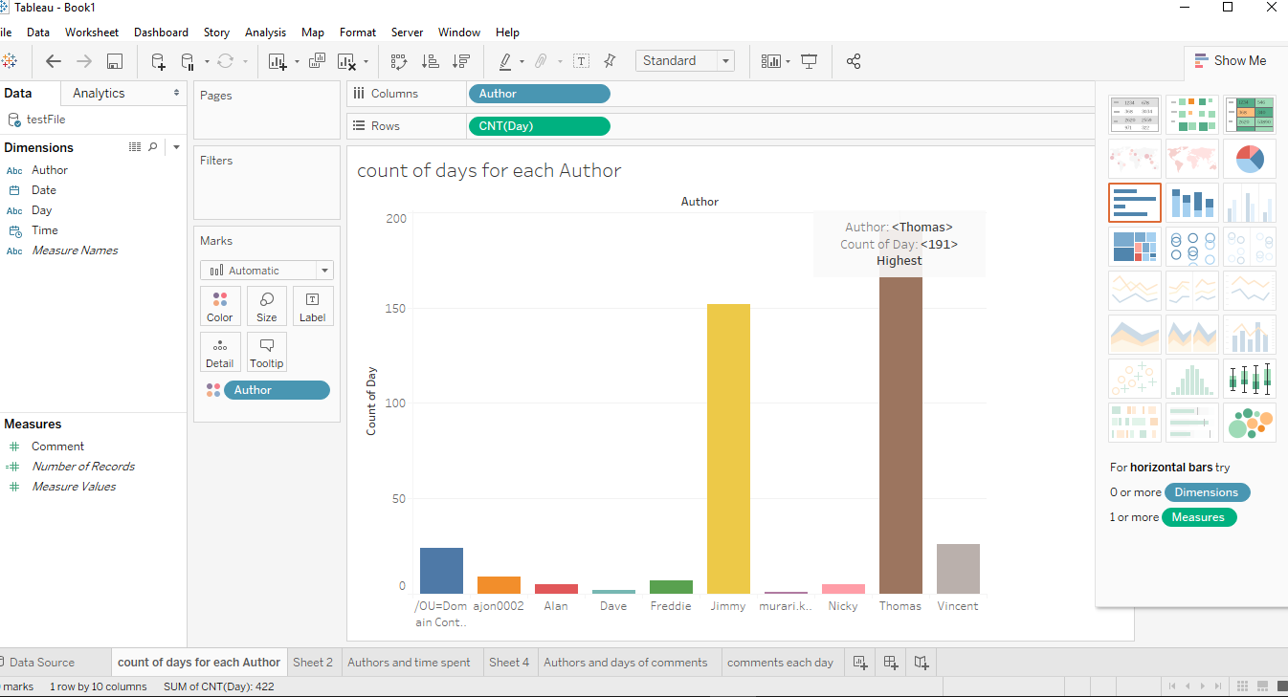

Though the highest commits were made on Thursday, the highest commit done was on Friday by Thomas with 68 comments. Freddie did the lowest on Wednesday, with 4 comments though he was not the lowest from the diagram below other authors are included. The lowest comment was one with more than one author.

